
Dashboard Design

Date | 21 September 2026
Team ID | MCA
Project Name | Strategic Employee Attrition Intelligence Board
Maximum Marks | 5 Marks

Creating an effective dashboard involves thoughtful design to ensure that the presented information is clear, relevant, and easily understandable for the intended audience. Here are some key principles and best practices for dashboard design
Activity 1: Interactive and visually appealing dashboards
Creating interactive and visually appealing dashboards involves a combination of thoughtful design, effective use of visual elements, and the incorporation of interactive features.

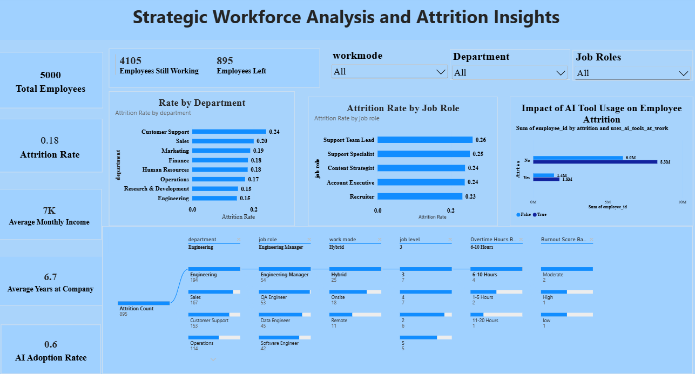
Here are five potential outcomes from the dashboard image provided:
Potential Outcomes
- Attrition Rate by Department: The dashboard compares attrition rates across departments and highlights variations in employee turnover.
- Attrition Rate by Job Role: The dashboard compares attrition rates across different job roles to identify variations in employee turnover.
- Impact of AI Tool Usage on Employee Attrition: The dashboard examines the relationship between AI tool usage and employee attrition.
- Attrition Count: The dashboard displays the total number of employees who have left the organization, providing an overall measure of employee turnover.
- KPI Cards: The KPI cards provide a quick summary of key employee metrics, including total employees, attrition count, and attrition rate, giving an overall view of workforce attrition.

